**Internet**

Table of Contents

Twisted Pair Cables 3

Fibre Optic Cables 4

TCP/IP Protocol 5

The internet is a network of networks. It connects separate networks together. ISPs connect users to the internet using co-axial cables. Recently, category 5 (CAT5) and category 6 (CAT6) cables are being used, which are twisted pair cables. The cable is connected to the router using a RJ45 connector.

## Twisted Pair Cables

These consist of 4 pairs of wires. Each pair is spirally twisted in order to reduce electromagnetic interference. 1 pair sends data, 1 pair receives data and 2 pairs help reduce electromagnetic interference. The maximum distance a twisted pair cable can cover is 100 meters. A repeated is needed for larger distances.

## Fibre Optic Cables

These work with the help of total internal reflection. They consist of 2 wires, one to receive data and one to send data. Fibre optic cables can cover a few thousand miles. If a part of the cable gets damaged, the entire part must be replaced. Repairing it is not an option since it may damage the cable’s data transfer capabilities.

Local Area Network (LAN): This is made with just CAT5 cables, connecting computers within the same network. An internet connection is not needed.

VSAT: This works as an alternative to the submarine cable. Satellite dishes are used to connect to satellites that allow access to the internet. Communication is very slow.

Mobile Networks: These provide internet access through mobile technology. Communication is very slow.

CPU sends data as electrical signals to the modem. The modem works as a converter, converting electrical signals to optical signals at one end and back again at the other end. Modems also maintain serial communication (data is sent bit by bit).

Data goes to the Internet Service Provider (ISP), which regulates speed and quality by user. If a user pays for a higher bandwidth, data is transferred faster. For lower bandwidths, the data is delayed. The ISP sends the data to a regional network, which connects to the terminal where connections to the submarine cables are managed. The submarine cables have a lot of channels.

## TCP/IP Protocol

In accordance with this protocol, data is broken into small packets to make it easier to handle data from a large number of users. If each user were to send a huge amount of data at once, it would become difficult to handle.

Each packet has a source address and a destination address attached to it (IP Addresses). The destination address is needed to know where to send the data. The source address is mostly used by the ISP at the receiving end, who makes sure that the destination user is allowed to access the data from the source.

Some applications connect users through the internet (such as chat applications). These are called network applications. In order to identify which application is sending and receiving data, the network application also requires an address, called a port.

The source IP address and port and the destination IP address and port make up a socket. A socket is just a connection between the two addresses.

Networks are connected to each other with the help of routers. Routers send data from the source network to the destination network. To send the data to the router, another layer of source and destination addresses are needed. The address of the router is called a gateway address. For each network ‘hop’, the immediate source and destination addresses are encapsulated at the source, and decapsulated at the destination.

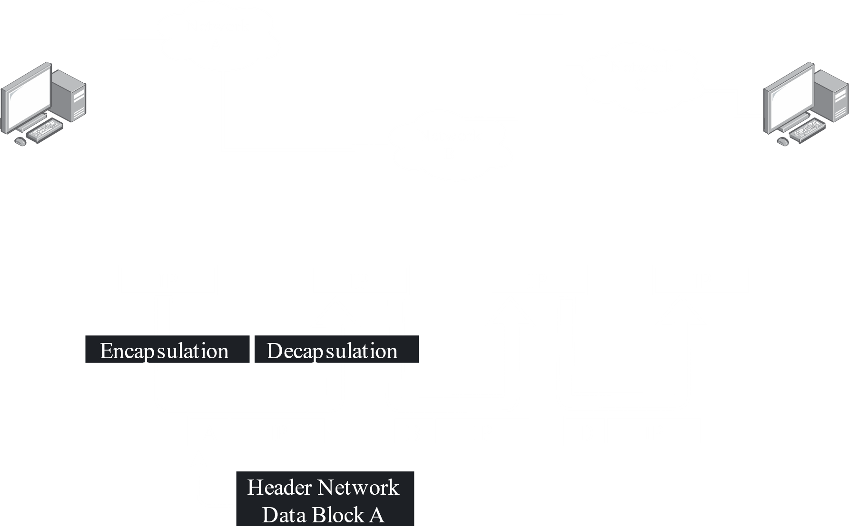

All of this can sometimes make data transfer within a local network slower. Some operating systems do not recognize that data is being sent to a device within the local network and sends it to the router instead, which then sends it back to the local network instead of sending the data to the internet. The encapsulation and decapsulations that take place in this process make the data transfer much slower than it would have been had the data just been sent directly.